TRAFFIC MANAGEMENT SYSTEM

PHASE 3

**SENSOR**

* Inductive loop sensor
* Infrared sensor
* Lidar sensor

**DATASETS**

There are several publicly available datasets for traffic management and analysis. Here are a few popular ones:

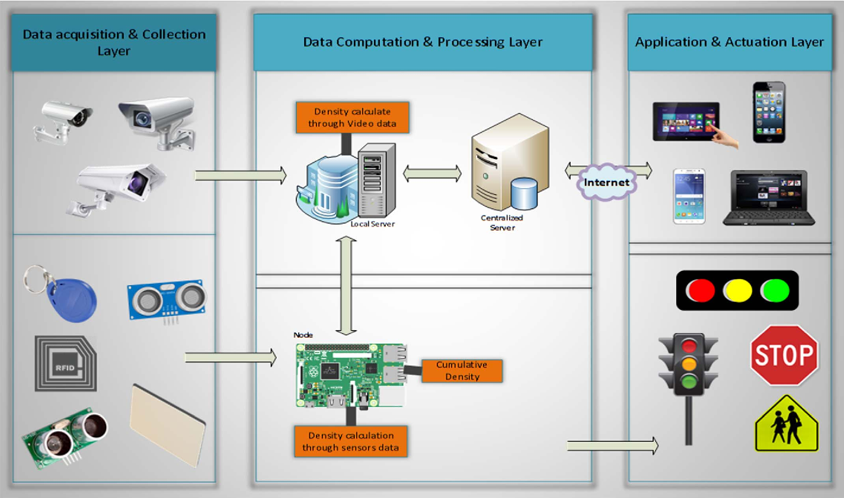

National Highway Traffic Safety Administration (NHTSA) Datasets: NHTSA provides datasets on various aspects of road safety, including crash data, vehicle recalls, and traffic fatality statistics.

Traffic Data Compendium: This dataset offers a wide range of traffic-related data, including vehicle counts, speeds, and road conditions, collected from various sources across the United States.

Bureau of Transportation Statistics (BTS): BTS offers datasets related to transportation, including air, sea, and road transport. You can find datasets related to traffic and road usage statistics.

NACTO (National Association of City Transportation Officials): NACTO provides data related to urban transportation and traffic management in various cities. They often share information about bike lanes, pedestrian paths, and traffic studies.

OpenStreetMap (OSM) Data: OSM is a crowdsourced map database that can be used to extract data about road networks, traffic signs, and other relevant information for traffic management.

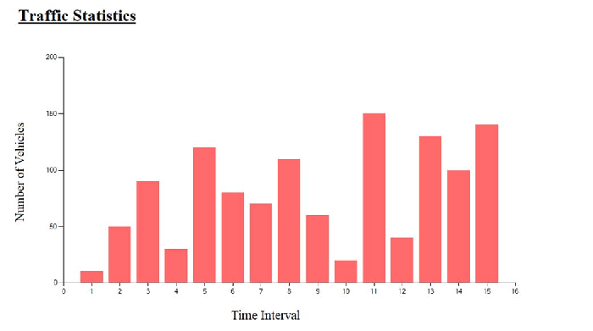

Kaggle: Kaggle often hosts datasets related to IoT and transportation. You can search for traffic management datasets there.

**MODEL RESULT**

The effectiveness of a traffic management system's model results can vary depending on the specific techniques and technologies employed. Here are some potential model results and their benefits:

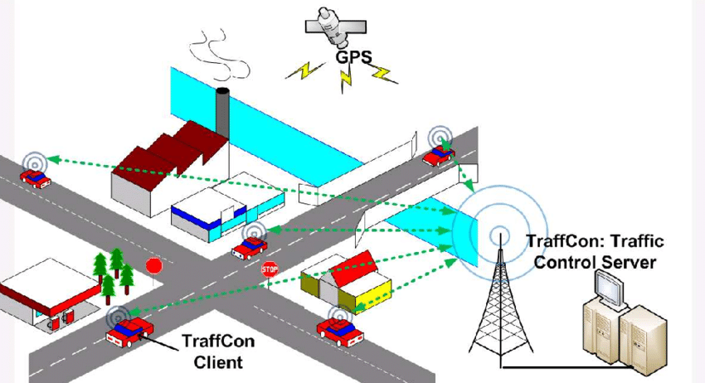

Reduced Congestion: An effective traffic management system should lead to reduced traffic congestion, shorter travel times, and smoother traffic flow. Model results may include data demonstrating a decrease in average travel times during peak hours.

Accident Detection and Response: IoT-based models can help in early accident detection and rapid response, minimizing traffic disruptions. The model results may show a decrease in accident-related traffic delays.

Improved Traffic Signal Timing: Model results can showcase optimized traffic signal timings, resulting in reduced waiting times at intersections and better traffic flow. This is often measured by improvements in the level of service at key junctions.

Energy Efficiency: Traffic management systems may contribute to energy savings by reducing unnecessary idling and stop-and-go traffic patterns. Model results can demonstrate reduced fuel consumption and lower emissions.

Enhanced Safety: Improved traffic management can lead to safer road conditions. Model results might include a decrease in the number of accidents or a reduction in the severity of accidents.